SENTIMENT ANALYSIS OF PRODUCT

REVIEWS

**Index**

|  |  |  |
| --- | --- | --- |
| **S. No** | **Title** | **Page No** |
| 1 | Introduction | 3 |
| 2 | Objectives | 4 |
| 3 | Implementation and Results | 5 |
| 4 | Conclusion | 11 |

**INTRODUCTION:**

Robotic process automation (or RPA) is a form of business process automation technology based on metaphorical software robots (bots) or on artificial intelligence (AI)/digital workers.[1] It is sometimes referred to as software robotics.

## Sentiment Analysis

Sentiment analysis (or opinion mining) is a natural language processing technique used to determine whether data is positive, negative or neutral. Sentiment analysis is often performed on textual data to help businesses monitor brand and product sentiment in customer feedback, and understand customer needs.

## Problem Statement:

Conduction of sentiment analysis on the user reviews of a product from an e-commerce website, using the concepts of machine learning, and Robotic Process Automation.

## Existing Methodology/System:

In order to perform sentiment analysis without using automation, we first need to write a machine learning/ deep learning model, collect a huge number of sentences in order to create a dataset, train the model using the gathered data, and perform validation.

Then we pass the sentences to the model as input, of which we want to find the sentiments. Then the model predicts the sentiment, with a certain amount of accuracy, precision, etc.

## Problems with the existing system:

The existing system needs a lot of human supervision, and is also considerably more error prone. This is because we need to keep updating the ML/DL model continuously, in order to maintain a high level of performance. Also, the existing system to predict the sentiments is not much user- friendly.

# OBJECTIVES:

Our objective is to perform sentiment analysis on the user reviews of a product from an e-commerce website using the concept of automation, and store it in an excel file, in order to access it easily.

We intend to utilize automation tools such as UiPath Studio, UiPath Orchestrator, and UiPath AI Center. We intend to lesser the influence of human factor to the said technological process, improved analysis’ reliability, and increase prediction and analysis speed and quality.

**UiPath Studio:** UiPath Studio is advanced automation software that gives everyone, from business users to advanced RPA developers, the right automation canvas to build great software robots—and organizations the right governance tools to manage them all.

**UiPath Orchestrator:** It is a web application that enables you to orchestrate your UiPath Robots in executing repetitive business processes. Orchestrator lets you manage the creation, monitoring, and deployment of resources in your environment. It acts as an integration point with third-party solutions and applications.

**UiPath AI Center:** AI Center is a service that allows you to deploy, manage, and continuously improve Machine Learning models and consume them within RPA workflows in Studio. The ML models can be built in a Python IDE or using an AutoML platform such as H20 Driverless AI.

# IMPLEMENTATION AND RESULTS:

1. Open UiPath orchestrator, sign in, and create a folder, and a robot, as shown below:

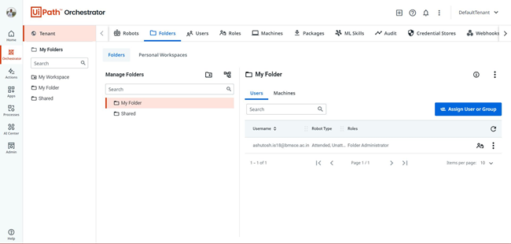

1. Open UiPath AI Center, create a new project with a name of your choice:

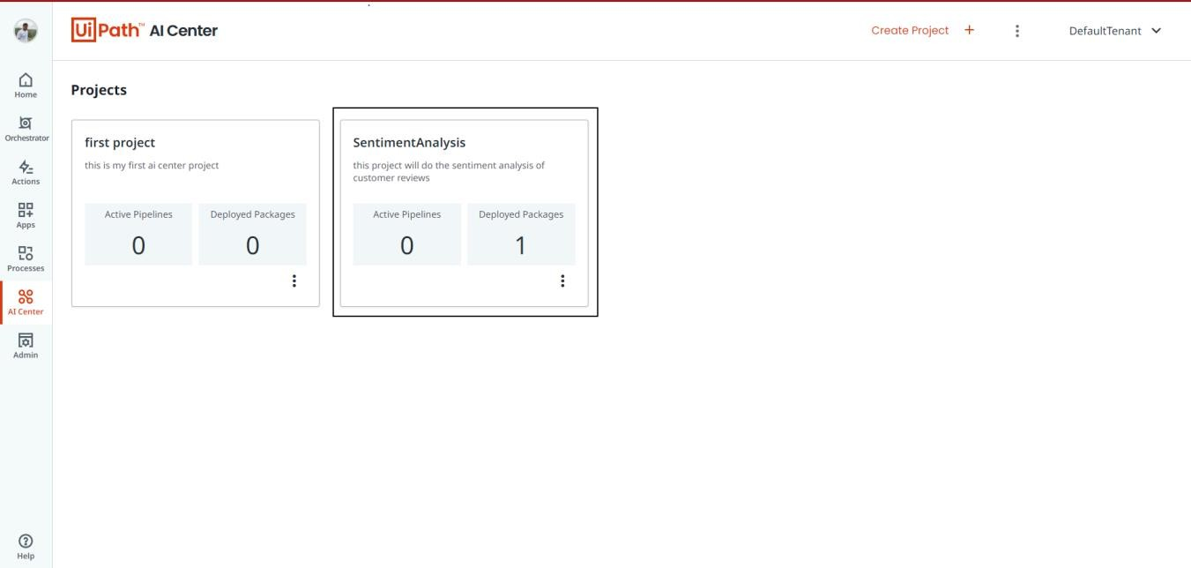

1. Click on the newly created project,click on ML packages, then click on “Out of the box Packages”, then click on “Language Analysis”. Then click on “SentimentAnalysis”. After that click on submit button, write a package name, and then click submit. You will have a ML package as shown below:

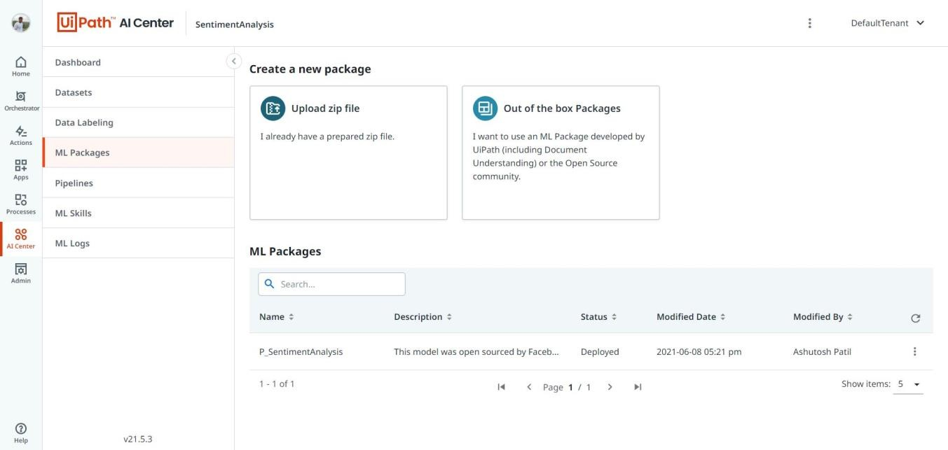

1. Click on ML skills, then click on “create new”. Give the skill a name, choose the previously created ML package, choose the correct versions, and click create. You will have created an ML skill as shown below:

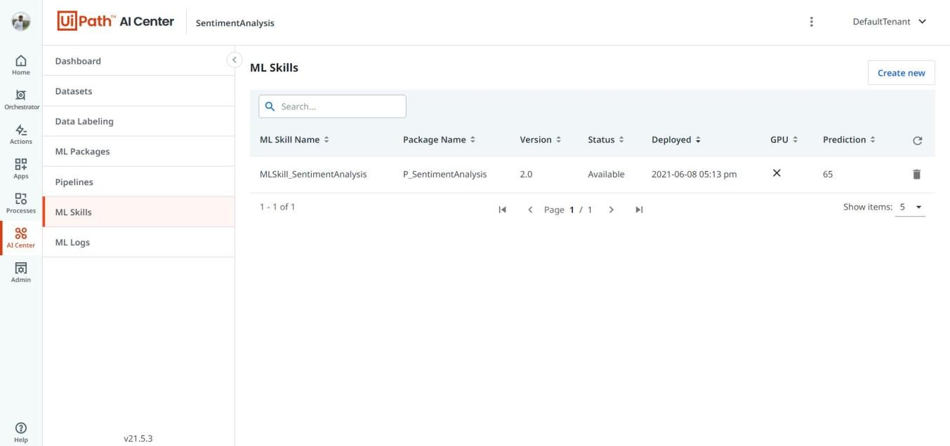

1. Open UiPath Studio, create a new blank process and name it. Install 2 packages, uipath.MLServices.Activities, and uipath.WebAPI.Activities. Create a new flowchart, with the elements as shown below:

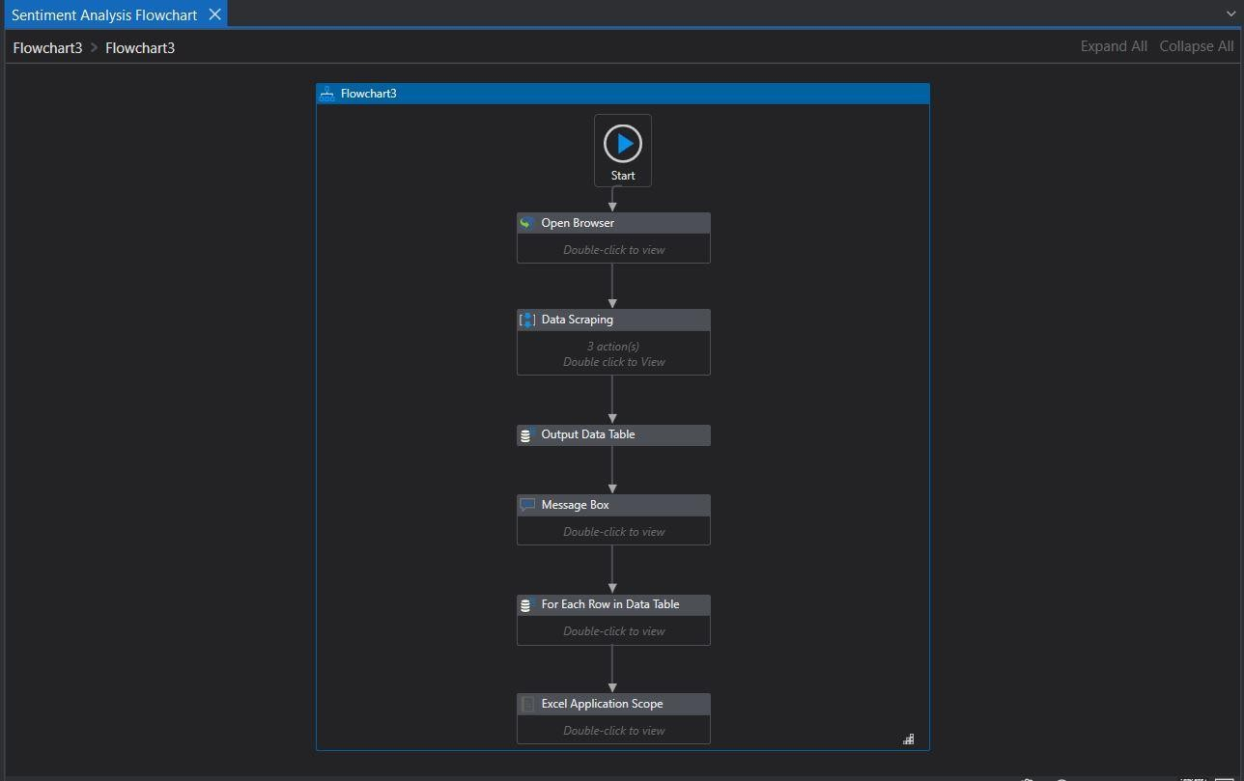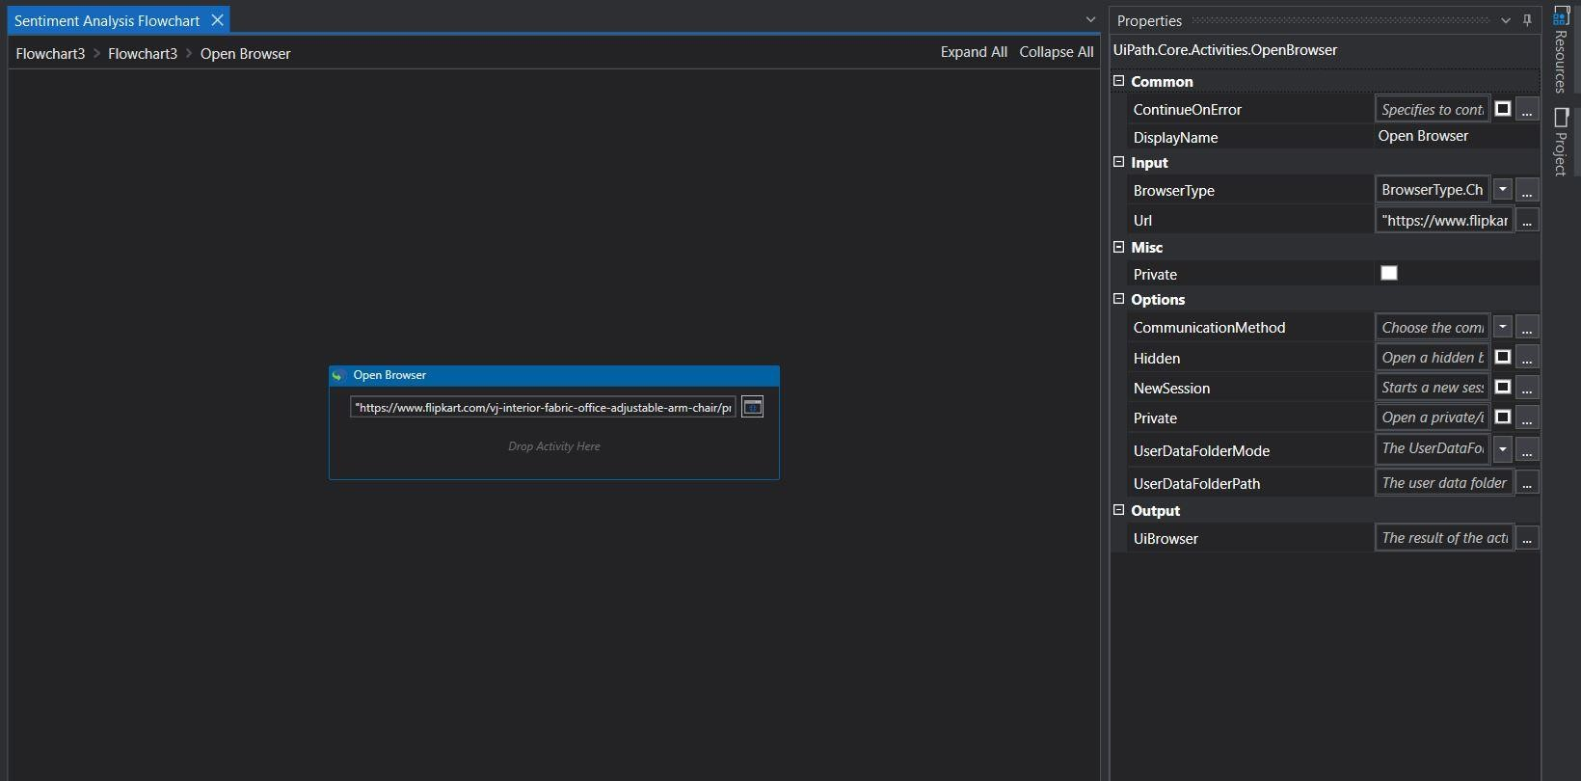

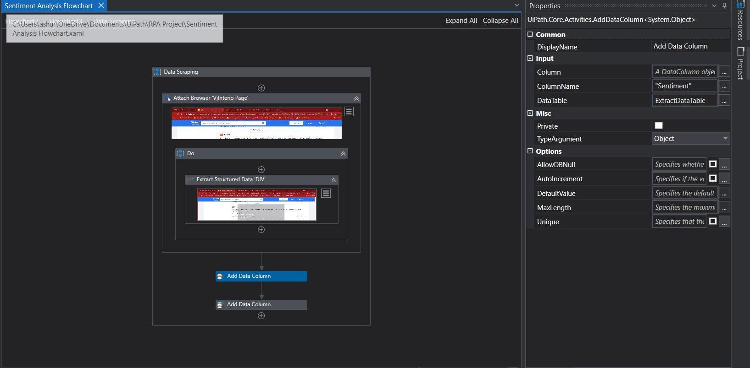

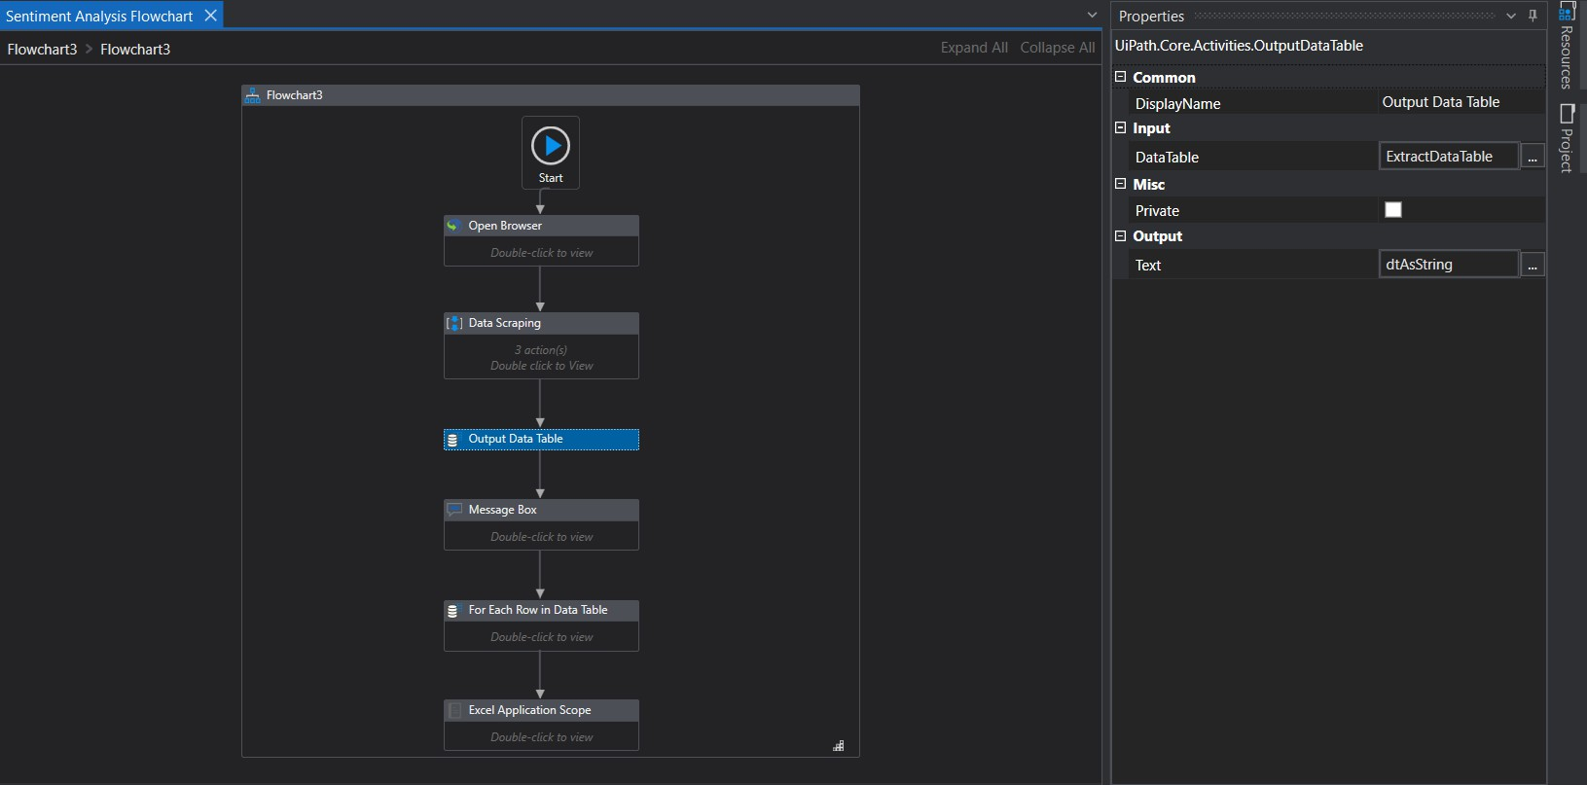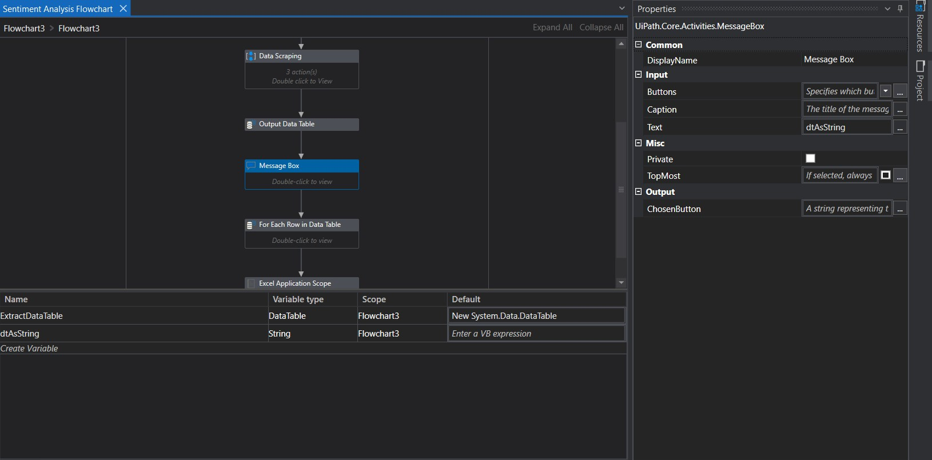

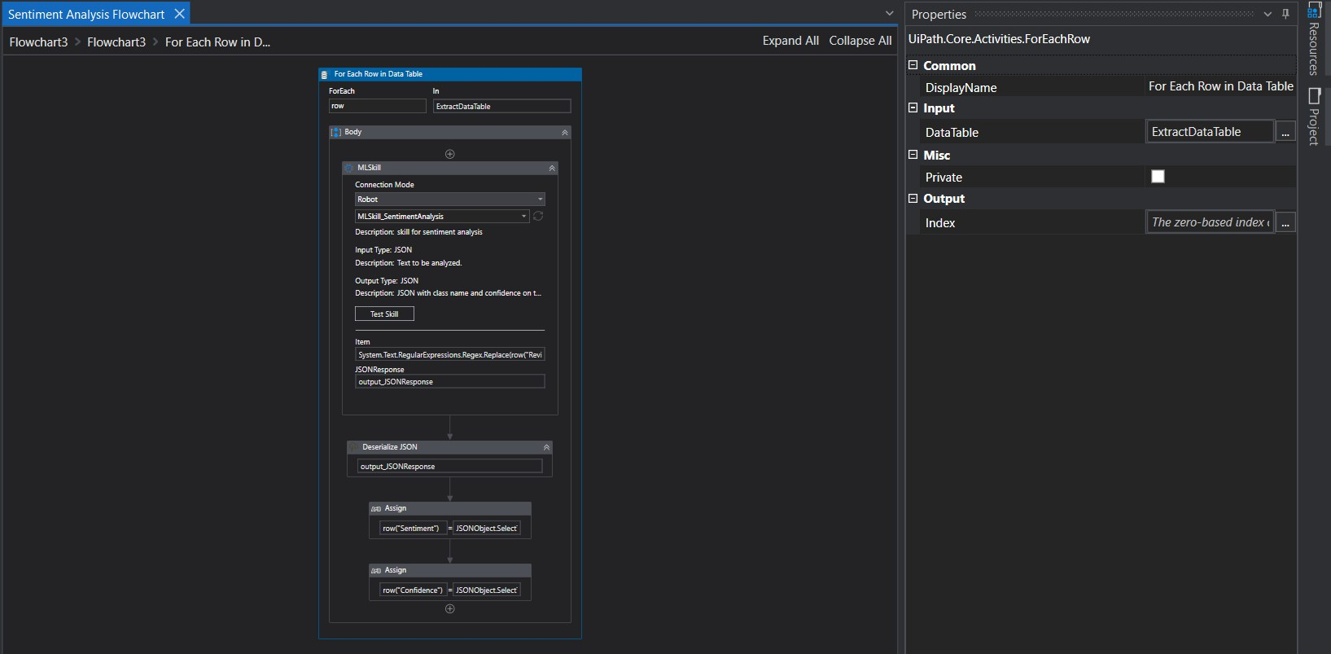

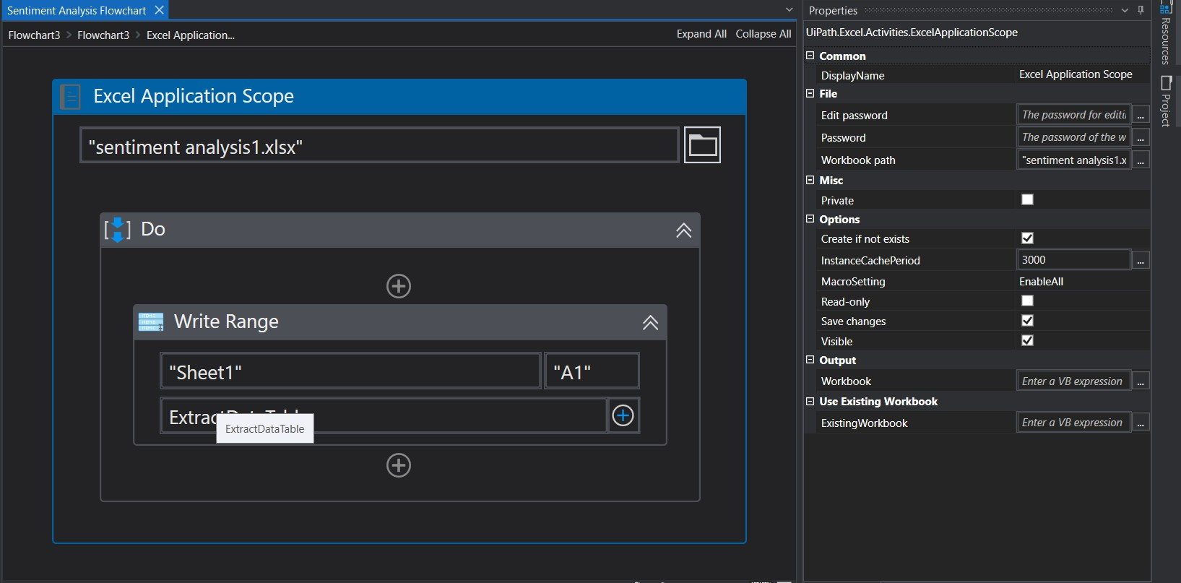

### Final Output:

We are taking reviews from this product from flipkart.com website:

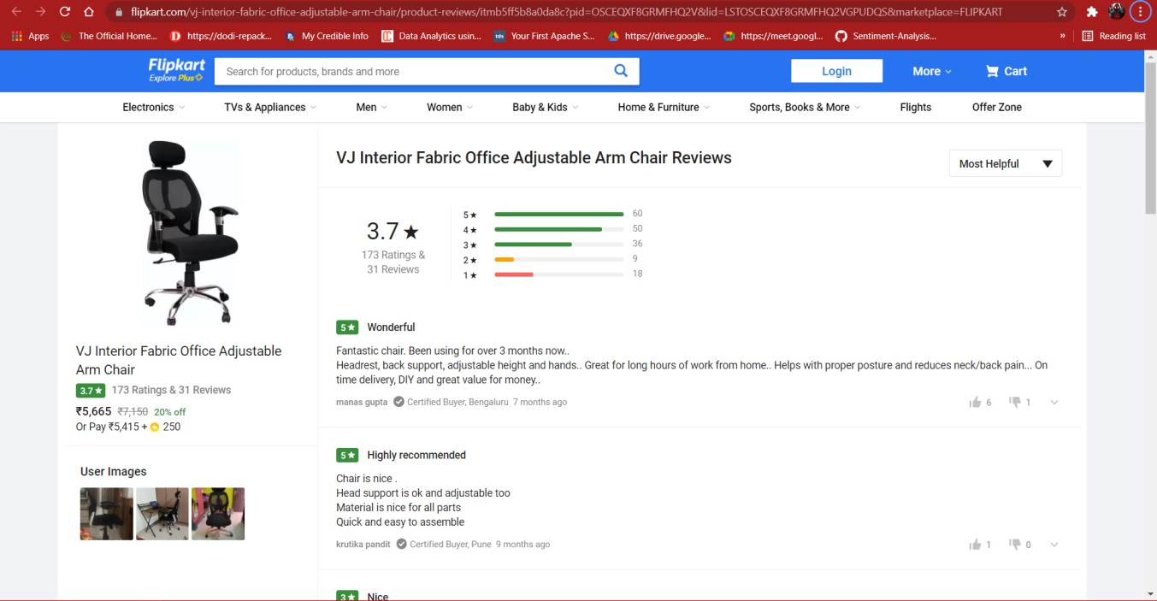

The sentiment predictions, and confidence scores of the reviews are stored in an excel sheet as follows:

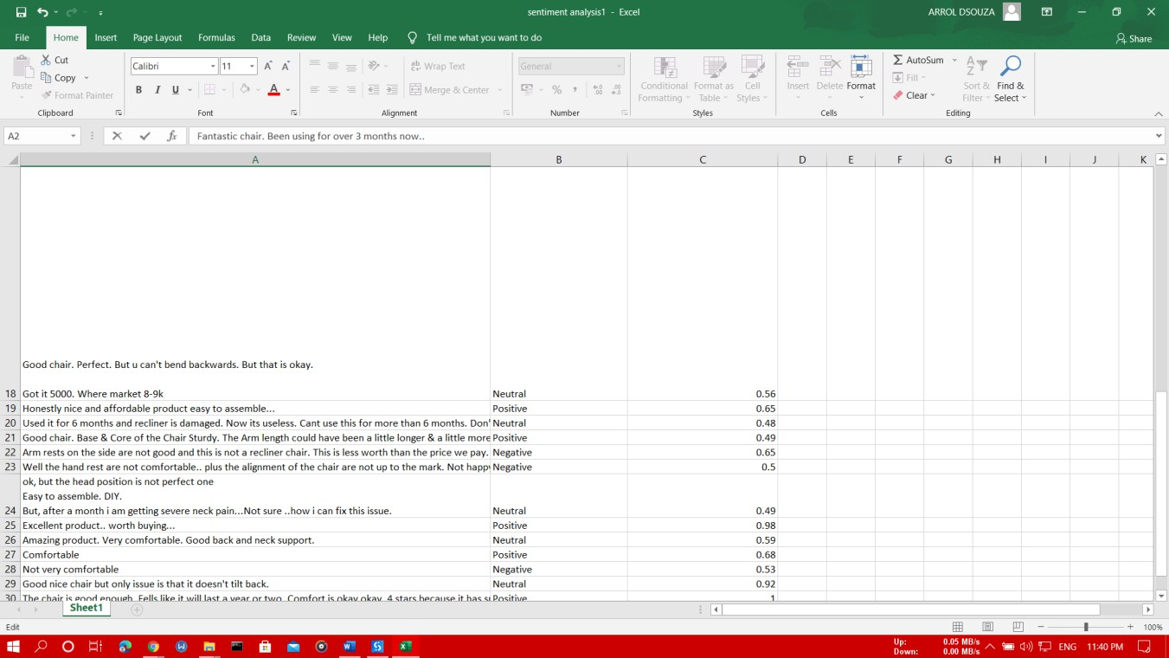

# CONCLUSION:

We were successfully able to predict the sentiments of the user reviews using the concepts of RPA. We were able to predict the sentiments and estimate the confidence of predictions, and store the results in an excel sheet.

The predictions were highly accurate, although, there were some wrong predictions, but they were mostly because of gramatical and spelling mistakes within the reviews.